**Mini Project Report on**



**RECOMMENDATION SYSTEM**



**Submitted in partial fulfillment of the requirement for the award of the degree of**

**BACHELOR OF TECHNOLOGY**

**IN**

**COMPUTER SCIENCE & ENGINEERING**

**Submitted by:**

**Student Name**  **University Roll No.**

**Aditya Semwal 2019528**

***Under the Mentorship of***

**MS VISHU TYAGI**

**(Assistant Professor)**



**Department of Computer Science and Engineering**

**Graphic Era (Deemed to be University)**

**Dehradun, Uttarakhand**

**January-2024**



**CANDIDATE’S DECLARATION**

I hereby certify that the work which is being presented in the project report entitled **“ RECOMMENDATION SYSTEM ”** in partial fulfillment of the requirements for the award of the Degree of Bachelor of Technology in Computer Science and Engineeringof the Graphic Era (Deemed to be University), Dehradun shall be carried out by the under the mentorship of **“Ms. Vishu Tyagi (Assistant professor)”**, Department of Computer Science and Engineering, Graphic Era (Deemed to be University), Dehradun.

Name University Roll no.

Aditya Semwal 2019528

**Table of Contents**

|  |  |  |
| --- | --- | --- |
| **Chapter No.** | **Description** | **Page No.** |
| Chapter 1 | Introduction | **1-2** |
| Chapter 2 | Literature Survey | **3** |
| Chapter 3 | Methodology | **4-7** |
| Chapter 4 | Result and Discussion | **8-9** |
| Chapter 5 | Conclusion and Future Work | **10-11** |
|  | References |  |

**Chapter 1**

**Introduction**

A recommendation system refers to an artificial intelligence (AI) algorithm, typically related to machine learning, that supports Big Data to propose or advocate for extra items to customers. These may be determined by several factors, such as demographic data, search history, previous purchases, and other considerations. Recommender systems are quite helpful since they let users find goods and services that they might not have found on their own.

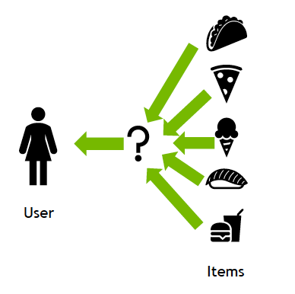

**Fig. 1.1 Recommended system**

* 1. **Problem Statement:**

Users are flooded with options on a wide range of online platforms in the current digital era, from social networking to streaming services and e-commerce. Finding relevant and customized information becomes more difficult for consumers as the amount of stuff available increases. A strong recommendation system that can wisely assess user preferences and behaviors and offer customized suggestions is required to solve this problem.

**1.2. Objective:**

In this project report, we examine how to apply machine learning algorithms to identify Recommended system in each sample of files. To validate the Recommendation system technique through machine learning which can achieve high accuracy. This report will present a project that uses machine learning algorithms to Recommend resources data set.

* 1. **. Roadmap**

Recommendation system project is a great example of how to apply machine learning algorithms to Recommend data from a data set. Additionally, the project can be extended and modified in various ways to suit different needs and applications. Overall, this report will provide a comprehensive overview of the recommendation system using machine learning, including the theory, software, and results, as well as potential application and future work.

**Chapter 2**

**Literature Survey**

**A review of the literature on recommendation systems covers an extensive range of subjects and academic articles that have been helpful in the creation and understanding of recommendation algorithms. Below is an overview of some important topics and seminal articles in the field:**

# **A survey on Recommendation System:**

# [**https://www.researchgate.net/publication/313787463_A_Survey_on_Recommendation_System**](https://www.researchgate.net/publication/313787463_A_Survey_on_Recommendation_System)

# **Evaluating Recommendations System:**

<https://link.springer.com/chapter/10.1007/978-0-387-85820-3_8>

* **E-learning Recommendation System**

[**https://ieeexplore.ieee.org/abstract/document/4722931**](https://ieeexplore.ieee.org/abstract/document/4722931)

* **Survey on Recommendation System Methods**

[**https://ieeexplore.ieee.org/abstract/document/7124857**](https://ieeexplore.ieee.org/abstract/document/7124857)

# **Recommender system application developments: A survey:**

<https://www.sciencedirect.com/science/article/abs/pii/S0167923615000627>

# **The impact of YouTube recommendation system on video views:**

<https://dl.acm.org/doi/abs/10.1145/1879141.1879193>

**Chapter 3**

**Methodology**

**3.1 Outline of the project**

The idea of machine learning is to let the algorithm analyze and learn by itself the best parameter from the data set to make good predictions. There are many different approaches to training a model to Recommend but in our case, we use Linear Kernal, Cosine Similarity and TfidfVectorizer from sklearn(machine learning library for python programming language)[1].

**3.2 Projects Functions**

**3.2.1 Initialization:**

The dataset is loaded from the file and is saved in memory using a python built-in library.

**import pandas as pd**

**from sklearn.feature_extraction.text import TfidfVectorizer**

**from sklearn.metrics.pairwise import linear_kernal**

**3.2.2 Feature Extraction:**

As machine learning algorithms only work on numeric values so features must be in numeric form. In our dataset there is a column called content which contains news texts. To reduce the preprocessing power, we remove extra or special characters as it will hinder our model to do so we will import some python libraries.

**def convert_views_to_numeric(views):**

**if 'K' in views:**

**return int(float(views.replace('K', '')) * 1000)**

**elif 'M' in views:**

**return int(float(views.replace('M', '')) * 1e6)**

**elif 'B' in views:**

**return int(float(views.replace('B', '')) * 1e9)**

**elif ' views' in views:**

**return int(''.join(filter(str.isdigit, views)))  # Extract numeric part**

**else:**

**return int(views)**

**def load_and_preprocess_data(file_path):**

**df = pd.read_csv(file_path, encoding='utf-16')**

**df['title'] = df['title'].str.lower().str.strip()**

**df['view'] = df['view'].str.replace(' views', '')**

**df['view'] = df['view'].apply(convert_views_to_numeric)**

**return df**

**3.2.3 Feature Selection:**

* **TfidfVectorizer:** The TfidfVectorizer is used for text feature extraction in natural language processing (NLP) and information retrieval tasks. It transforms a collection of text documents into a numerical representation suitable for machine learning algorithms, allowing them to work with textual data effectively.
* **Linear Kernal:** A linear kernel, which is frequently employed in machine learning, is a tool for calculating the similarity between pairs of data points in a dataset. By computing the dot product of the feature vectors of the data points, it depicts a linear relationship between them. In essence, it facilitates algorithms' comprehension of the degree to which two data points align in a straight line, which is helpful for tasks like regression or classification.

**3.2.4. Recommendation System:**

Streamlit is an open-source Python library that allows data scientists and developers to create web applications for data visualization and interactive data exploration with minimal effort. It is designed to turn data scripts into shareable web applications quickly and easily.

With Streamlit, you can transform Python scripts that produce charts, plots, dataframes, and other visualizations into web apps with just a few lines of code. It eliminates the need for HTML, CSS, or JavaScript, making it accessible to those with little to no web development experience

**def display_recommendations(predictions):**

**predictions=predictions.sort_values(by='view',ascending=False)**

**st.write(predictions)**

**# Main Streamlit app**

**def main():**

**st.title('Content-Based Video Recommender System')**

**file_path = "dataset.csv"**

**df = load(file_path)**

**input_title = st.text_input('Enter a video title')**

**if st.button("Get Recommendations"):**

**predictions = recommend(df, input_title)**

**display_recommendations(predictions)**

**Fig. 3.1 Content based Recommendation system**

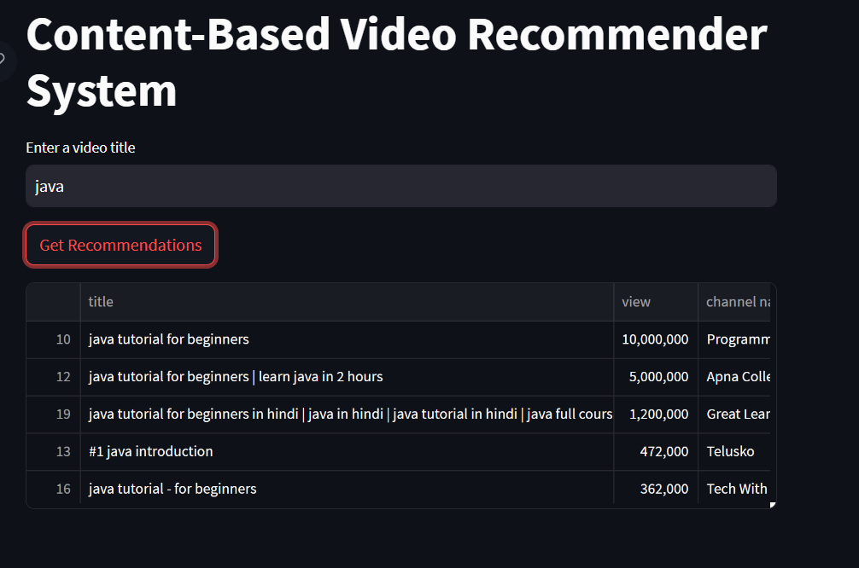

**Fig. 3.2 recommending some java related videos**

**Fig. 3.3 Recommending javascript based videos**

**Chapter 4**

**Result and Discussion**

By using the above algorithm, we can be able to recommend a user videos according to their need.

**Fig. 3.1 content based recommendation system**



**Fig. 3.2 recommending some java related videos**

**Fig. 3.3 Recommending javascript based videos**

**Chapter 5**

**Conclusion and Future Work**

**5.1 Conclusion:**

Machine learning can be an effective tool for recommendation on internet. Overall, Ml-based Recommendation techniques can achieve high accuracy rates and can adapt to new and evolving technologies

Proper technique should be used on a given dataset to achieve high accuracy.

**5.2 Future scope**

The future scope of using machine learning for Recommendation system is very promising. Machine learning algorithms can be trained on large sets of data to identify patterns making them well-suited for the task of Recommendation.

Additionally, machine learning-based Recommendation systems can be continuously updated with new data and improve over time.

**5.3 Future Work**

There are several areas of future work in the field of machine learning algorithms for Recommendation system.

Recommendation system using machine learning is an evolving area of research with ongoing advancements and future opportunities for improvement. Here are some potential areas of future work to enhance the effectiveness of Recommendation system:

* **Dataset Improvement**:

Continue to curate and expand high-quality labeled datasets for training and evaluating Recommendation models. Large and diverse datasets can help improve the generalization and robustness of the models.

* **Multimodal Analysis:**

Investigate the fusion of textual features with other modalities, such as images, videos, and social network data, to build Recommendation system models.

* **Online Learning:**

Design algorithms that can adapt to dynamic environments and continuously update their knowledge as new data becomes available.

Overall, the Recommendation system has the potential to significantly advance due to the continual development of machine learning algorithms, the availability of big datasets, and the combined efforts of researchers and practitioners. The ability to create more reliable and precise models to counteract false information grows more and more attractive as technology develops.

**References:**

# **A survey on Recommendation System:**

# [**https://www.researchgate.net/publication/313787463_A_Survey_on_Recommendation_System**](https://www.researchgate.net/publication/313787463_A_Survey_on_Recommendation_System)

# **Evaluating Recommendations System:**

<https://link.springer.com/chapter/10.1007/978-0-387-85820-3_8>

* **E-learning Recommendation System**

[**https://ieeexplore.ieee.org/abstract/document/4722931**](https://ieeexplore.ieee.org/abstract/document/4722931)

* **Survey on Recommendation System Methods**

[**https://ieeexplore.ieee.org/abstract/document/7124857**](https://ieeexplore.ieee.org/abstract/document/7124857)

# **Recommender system application developments: A survey:**

<https://www.sciencedirect.com/science/article/abs/pii/S0167923615000627>

# **The impact of YouTube recommendation system on video views:**

<https://dl.acm.org/doi/abs/10.1145/1879141.1879193>